[](https://www.google.nl/imgres?imgurl=https%3A%2F%2Frndr.juniqe-production.juniqe.com%2Fmedia%2Fcatalog%2Fproduct%2Fcache%2Fx600%2F545%2F13%2F545-13-401P.jpg&imgrefurl=https%3A%2F%2Fwww.juniqe.nl%2Fso-retro-posters-1279010.html&docid=mLFFnMFaDTsQTM&tbnid=O0ClXzoFZs_D1M%3A&vet=10ahUKEwicr4yCqOTlAhVIKewKHe36CEUQMwiTASgjMCM..i&w=408&h=600&bih=663&biw=1190&q=retro&ved=0ahUKEwicr4yCqOTlAhVIKewKHe36CEUQMwiTASgjMCM&iact=mrc&uact=8)

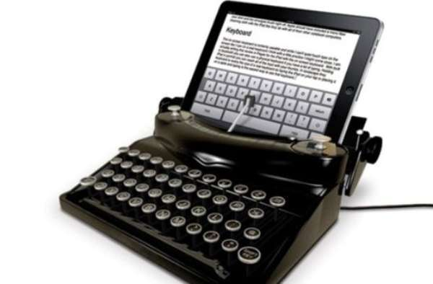[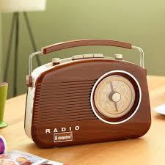](https://www.google.nl/url?sa=i&rct=j&q=&esrc=s&source=images&cd=&cad=rja&uact=8&ved=2ahUKEwiNnLrvpuTlAhUBMewKHfMDALUQjRx6BAgBEAQ&url=%2Furl%3Fsa%3Di%26rct%3Dj%26q%3D%26esrc%3Ds%26source%3Dimages%26cd%3D%26ved%3D2ahUKEwj3mMyupOTlAhWFyqQKHdSVD5sQjRx6BAgBEAQ%26url%3Dhttps%253A%252F%252Funiqueelectronicgifts.co.uk%252Fproduct%252Fbrighton-model-retro-radio-wood-model%252F%26psig%3DAOvVaw1zkcbS7ZsU81mW1zQidHwh%26ust%3D1573634735499957&psig=AOvVaw1zkcbS7ZsU81mW1zQidHwh&ust=1573634735499957)